**Basic**

1. Create terraform module which creates vpc, public subnets, private subnets, nat gateway, internet gateway, routes.  
   Module should take next input variables:

* name
* vpc cidr
* private subnets cidrs
* public subnets cidrs Module should always create at least one public subnet and do not allow create zero public subnets.  
  Private subnets are not obligatory.

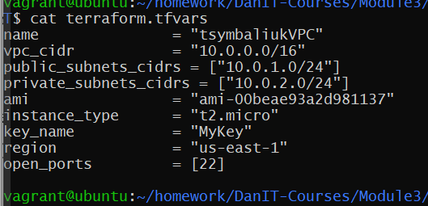

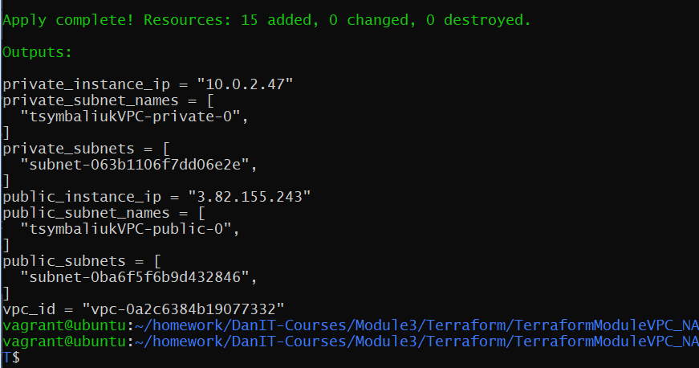

1. With this module create vpc and one ec2 in private subnet and one in public

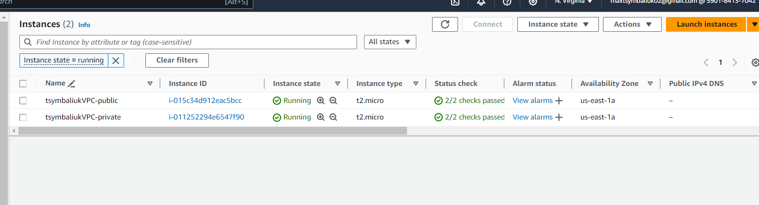

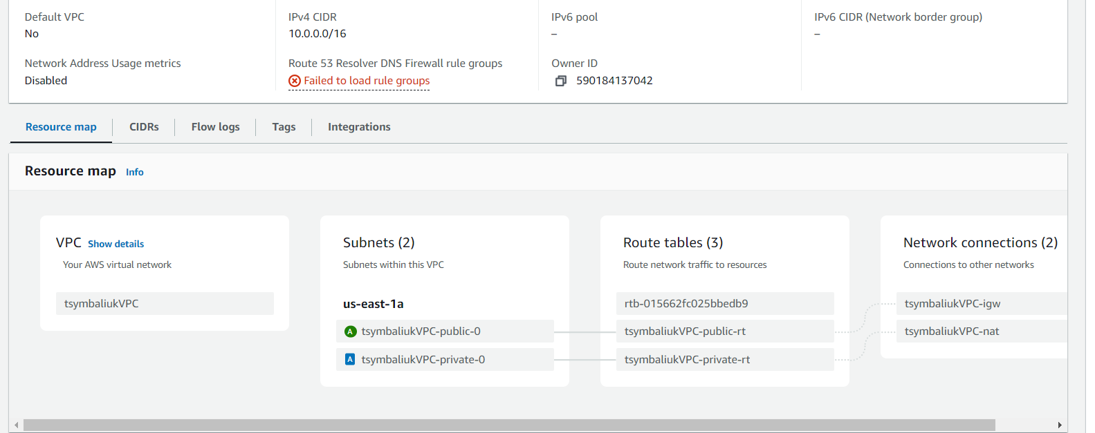

1. Destroy infrastructure

